Special Educational Needs and Disability

Types of SEND
What do we mean by SEND?
​
SEND (Special Educational Needs and Disability) the needs of children who have a difficulty or disability which makes learning harder for them than other children of the same age. SEN can cover a broad range of difficulty or disability and children may have wider ranging or specific problems. These may relate to physical development, visual or hearing impairment or difficulties related to speech and language communication, behaviour or learning.
​
Many children will have special educational needs of some kind during their time in education. Most children can be helped to overcome the barriers their difficulties present quickly and easily but some children will need extra help for some or all of their time in education.
The needs of the child are normally achieved through the teacher’s/practitioner’s knowledge of a child’s strengths, skills and abilities.

If it is decided that your child needs help beyond that which is normally available, or your child needs interventions that are additional to and different from those normally provided as part of the curriculum, the school/setting may contact the local authority for extra guidance and support.
​
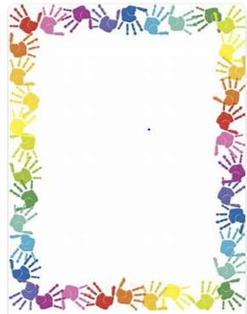
Most children and young people will have their special educational needs met in mainstream schools through good classroom practice.
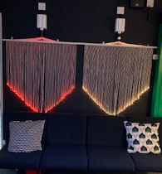
This is called Quality First Teaching.

​

There are four broad areas of
Special Educational Needs and Disabilities:

Communication and Interaction
This area of need includes children with Autism Spectrum Condition and those with Speech, Language and Communication Needs
​
Cognition and Learning
This includes children with Specific Learning Difficulties, Moderate Learning Difficulties, Severe Learning Difficulties and Profound and Multiple Learning Difficulties
​
Social, Emotional and Mental Health Difficulties
This includes any pupils who have an emotional, social or mental health need that is impacting on their ability to learn
​
Sensory and/or Physical Difficulties
This area includes children with hearing impairment, visual impairment, multi-sensory impairment and physical difficulties.
​
​

At Green Lane Infants we follow a graduated support approach which is called, “Assess, Plan, Do, Review”.

This means that we will:

- Assess a child’s special educational needs
- Plan the provision to meet your child’s aspirations and agreed outcomes
- Do put the provision in place to meet those outcomes
- Review the support and progress
​
As part of this approach, we will produce a SEN Support Plan that describes the provision that we will make to meet a child’s special educational needs and agreed outcomes. Parents and carers will be involved in this process.
​
A small percentage of children and young people with significant learning difficulties might need an assessment that could lead to an Education, Health and Care Plan.

Our experience of supporting children and young people with a wide-range of needs includes pupils with:

- Autistic Spectrum Disorders
- Social Emotional and Behavioural difficulties
- Speech and Language
- Moderate Learning Difficulties
​
The school provides data on the levels and types of need to the Local Authority.
This is collected through the school census. Children who are a concern or have recently been removed from the SEN register will be placed on a monitor register.
​

