Art and Design at Home Guide
Opportunities and Aspirations for the future
Curator, interior designer, hair and make-up artist, costume designer, illustrator, graphic designer, photographer or even designing the World Cup football, there are many exciting careers within the field of art and design.
Here is a link to BBC Bitesize where you can find a list of possible careers and interviews with people working within art and design.
BBC Bitesize – jobs that use art and design

Websites to visit to support your child
BBC Bitesize has some great videos with information about artists and different media
Google’s arts and culture guide lets you explore lots of famous artwork and galleries
Learn to draw online with Paul Carney
Make your own playdough following this Youtube tutorial. There are many useful and inspiring videos on the app.
Rob Biddulph is a famous author and illustrator. Learn step by step how to draw like him.
The Royal Academy lets you virtually visit their Picasso exhibition.

Local Places to Visit
There are many places, local to Leicester which you could visit with your child to develop their knowledge and enthusiasm for art and design
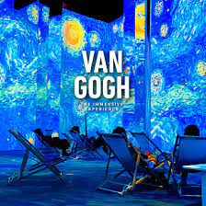
This incredible, immersive experience is just a short walk from the city centre. It uses digital technology to make you feel as if you are really inside Van Gogh’s paintings.
https://www.vangoghexpo.co.uk/leicester/
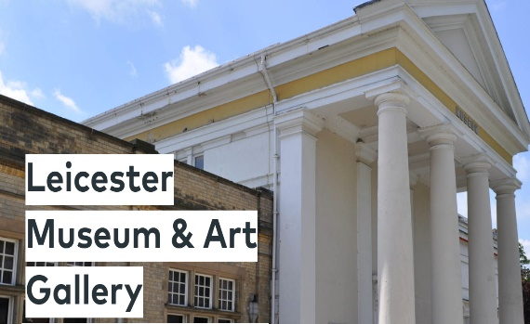
.
At the Leicester Museum and Art Gallery you can visit the Victorian Art Gallery, Arts & Crafts Gallery, Picasso Ceramics: The Attenborough Collection and Leicester's internationally renowned German Expressionism collection. There are also various workshops and special events throughout the year. https://www.leicestermuseums.org/leicester-museum-art-gallery/
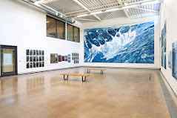
Attenborough Arts Centre has lots of events throughout the year including family workshops.
https://attenborougharts.com/

As well as being a small, independent cinema, the Phoenix also has a brilliant arts centre that hosts lots of exhibitions and family sessions.
https://www.phoenix.org.uk/

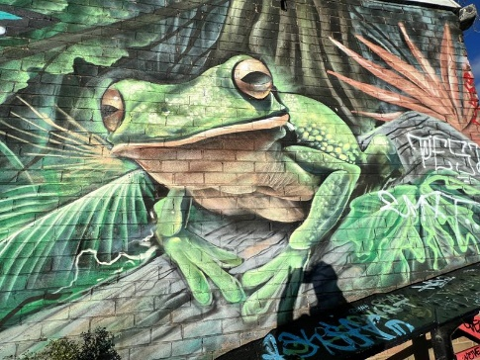
There is inspiring street art all over Leicester City and the best part is, you can walk around and enjoy it all for free!
You can buy a guide to Leicester’s street art for £3.50 at the King Richard III visitor centre.
Visit Leicester – Spectacular Street Art
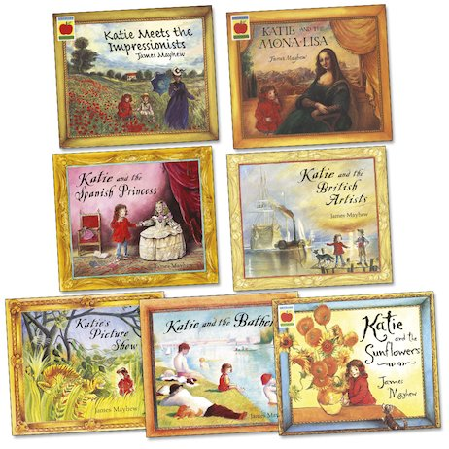
Books to read
James Mayhew’s collection of books allows you to follow the story of Katie as she adventures inside famous artworks throughout history.

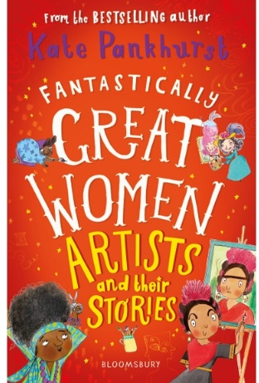
Find out more about famous female artists and their work.

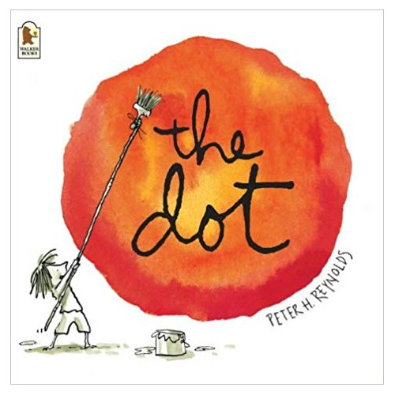

The Dot has an inspiring message of resilience, telling us we can all be artists.
One of our favourite artists at Green Lane, we love this book.

Find out more about some of the world’s most famous artists in this wonderful book from the Little People Big Dreams collection.

