Special Educational Needs and Disability

Assessment on Entry/Early Identification
When a child enters the School, we will gather paperwork from any previous settings and ask the parents/carers whether they have any SEND or broader concerns. In Early Years, the class teacher will also complete a home visit to get to know the children and to discuss their needs with their parents/carers. We recognise that parents know their children best and it is important to listen and understand when parents express concerns about their child’s development. We further assess all children during their first half-term in our school through careful and sensitive classroom observation and an early review of progress.
Initial Concerns
At any time, teachers, parents/carers, the Inclusion Lead and Head teacher are available to hear or raise concerns about a child and to act accordingly. Throughout the year we conduct sensitive classroom observations and thorough curriculum assessments, encouraging the different staff who come into contact with a child to share their observations. We listen carefully to what staff, children and parents tell us at any time during the year. However, we also have a very clear timetable in place to ensure that we gather and evaluate all of the information about every child and use a graduated system to plan adequate support for all. This process is facilitated by a series of termly meetings.
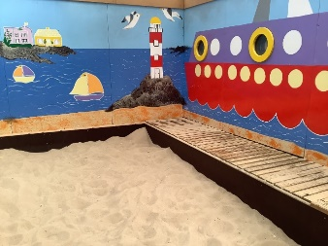

How does the school know if my child needs extra help?
We have a number of methods to help us identify if a child needs extra help. Children are assessed regularly by the class teacher. Every class teacher has an identification pack to help them ascertain the specific need of the child. If a child is having difficulties in a particular area the child’s class teacher will put in place interventions to support the child. If after this the child still requires support then their individual needs will be discussed with Mrs Shaw and an Pupil Profile will be put in place. This will then be discussed with the child’s parents.
Green Lane Infants Pathway to identifying needs
Who do I contact if I think my child has special needs?
If you think your child may have a special educational need then you should speak to your child's class teacher or contact the school Inclusion Lead, Mrs Shaw. She is generally available on Wednesday, Thursday and Friday or you could ring school to leave a message for her to contact you. If it is agreed that your child needs extra help and support, a discussion will take place with the teaching staff who work with your child and Mrs Shaw. Your knowledge and views will be taken into account in planning any support for your child and following this discussion an action plan will be agreed.
How would the school support my child to overcome barriers?
Support is tailor made to meet the needs of your child. This support may include:-
Additional support from a Teaching Assistant (1:1 or small group)
Additional physical resources used e.g. ICT, writing aids, visual timetable
Adaptations to the curriculum
Shortened activities
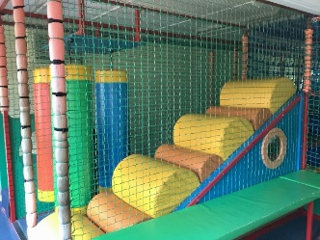
Own workstation
Changes to the timetable
Adapted PE equipment,
Ear defenders,
Quiet spaces.

Link to guidance:
Equality Act 2010: guidance - GOV.UK (www.gov.uk)

