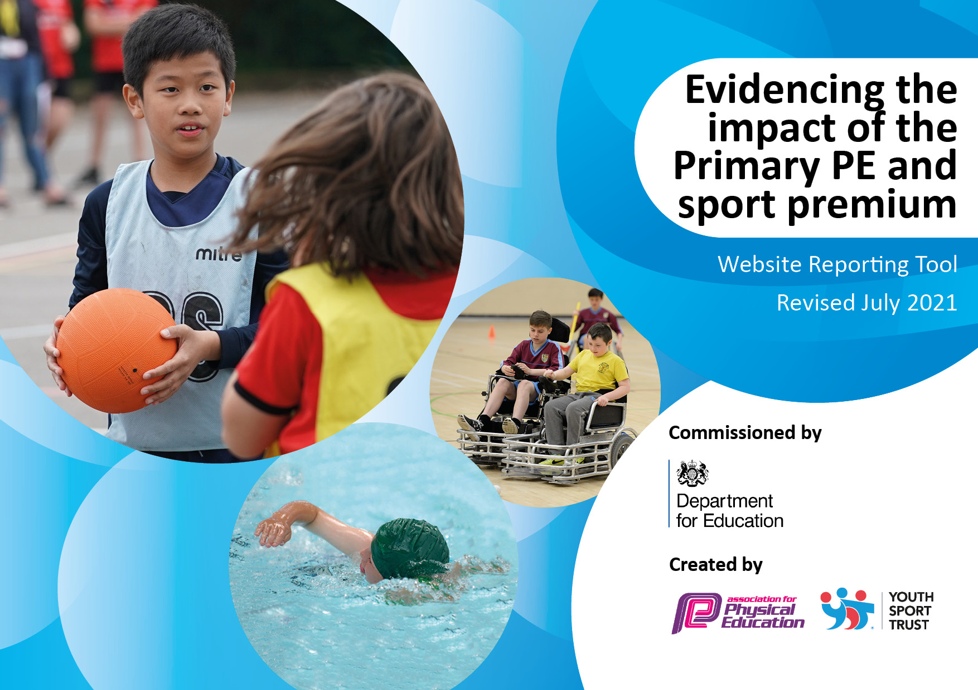
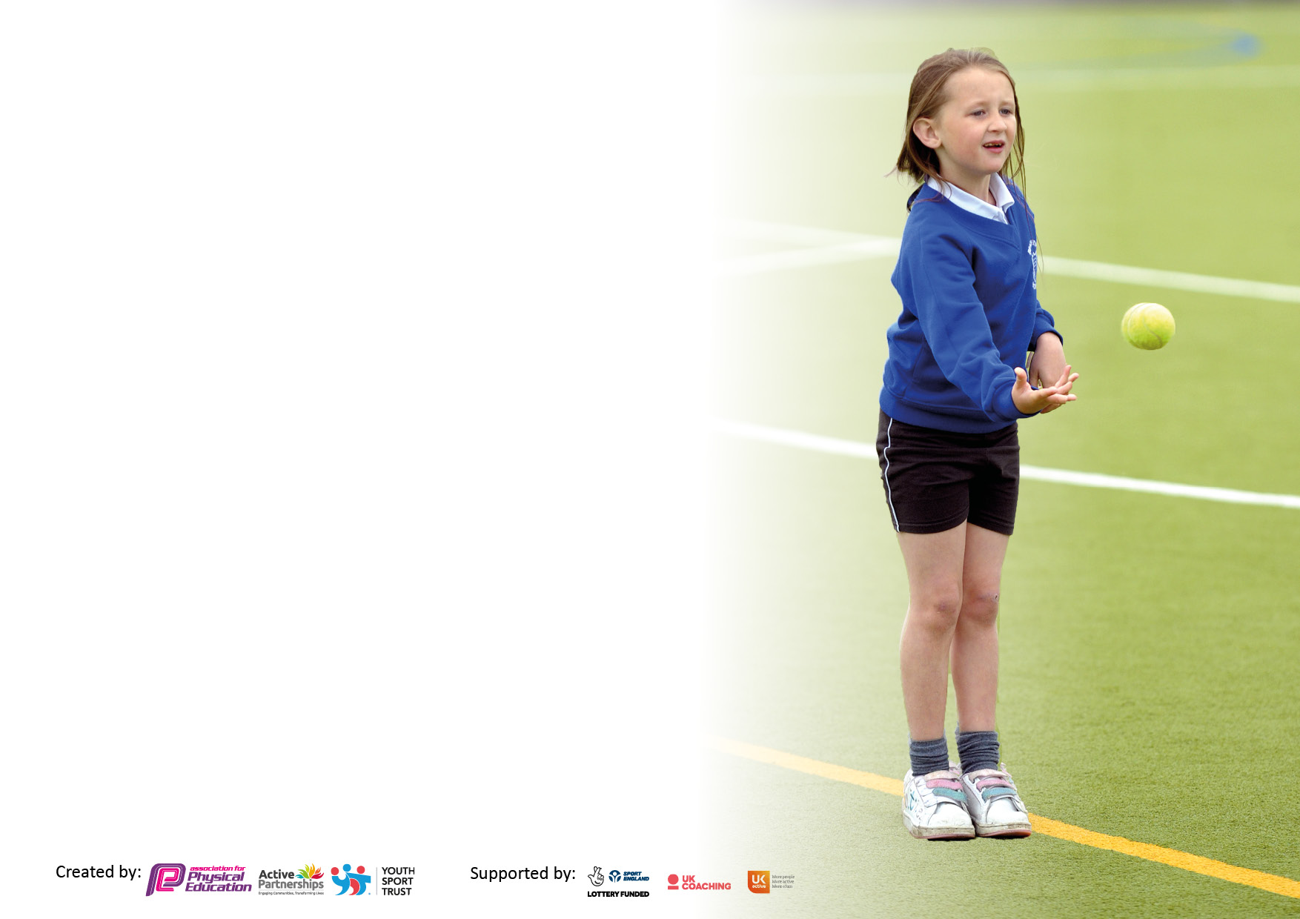

It is important that your grant is used effectively and based on school need. The Education Inspection Framework makes clear there will be a focus on ‘whether leaders and those responsible for governors all understand their respective roles and perform these in a way that enhances the effectiveness of the school’.

Under the Quality of Education Ofsted inspectors consider:
Intent - Curriculum design, coverage and appropriateness
Implementation - Curriculum delivery, Teaching (pedagogy) and Assessment
Impact - Attainment and progress

To assist schools with common transferable language this template has been developed to utilise the same three headings which should make your plans easily transferable between working documents.

Schools must use the funding to make additional and sustainable improvements to the quality of Physical Education, School Sport and Physical Activity (PESSPA) they offer. This means that you should use the Primary PE and sport premium to:

- Develop or add to the PESSPA activities that your school already offer
- Build capacity and capability within the school to ensure that improvements made now will benefit pupils joining the school in future years
- The Primary PE and sport premium should not be used to fund capital spend projects; the school’s budget should fund these.

Pleasevisitgov.ukfortherevisedDfEguidanceincludingthe5keyindicatorsacrosswhichschoolsshoulddemonstrate animprovement.Thisdocumentwillhelpyoutoreviewyourprovisionandtoreportyourspend.DfEencouragesschools to use this template as an effective way of meeting the reporting requirements of the Primary PE and sport premium.

We recommend you start by reflecting on the impact of current provision and reviewing the previous spend.

Schools are required to publish details of how they spend this funding, including any under-spend from 2019/2020, as well as on the impact it has on pupils’ PE and sport participation and attainment. All funding must be spent by 31st July 2022.

We recommend regularly updating the table and publishing it on your website throughout the year. This evidences your ongoing self-evaluation of how you are using the funding to secure maximum, sustainable impact. Final copy must be posted on your website by the end of the academic year and no later than the 31st July 2021. To see an example of how to complete the table please click HERE.

Details with regard to funding
Please complete the table below.

Total amount carried over from 2019/20 | £0
Total amount allocated for 2020/21 | £17,780
How much (if any) do you intend to carry over from this total fund into 2021/22? | £0
Total amount allocated for 2021/22 | £17,780
Total amount of funding for 2021/22. To be spent and reported on by 31st July 2022. | £17,780
Swimming Data
Please report on your Swimming Data below.

Meeting national curriculum requirements for swimming and water safety.  N.B. Complete this section to your best ability. For example you might have practised safe self-rescue techniques on dry land which you can then transfer to the pool when school swimming restarts.  Due to exceptional circumstances priority should be given to ensuring that pupils can perform safe self rescue even if they do not fully meet the first two requirements of the NC programme of study | Not applicable as an infant school
What percentage of your current Year 6 cohort swim competently, confidently and proficiently over a distance of at least 25 metres?  N.B. Even though your pupils may swim in another year please report on their attainment on leaving primary school at the end of the summer term 2020.  Please see note above | Not applicable as an infant school
What percentage of your current Year 6 cohort use a range of strokes effectively [for example, front crawl, backstroke and breaststroke]?  Please see note above | Not applicable as an infant school
What percentage of your current Year 6 cohort perform safe self-rescue in different water-based situations? | Not applicable as an infant school
Schools can choose to use the Primary PE and sport premium to provide additional provision for swimming but this must be for activity over and above the national curriculum requirements. Have you used it in this way? | Not applicable as an infant school

Action Plan and Budget Tracking
Capture your intended annual spend against the 5 key indicators. Clarify the success criteria and evidence of impact that you intend to measure to evaluate for pupils today and for the future.

Academic Year: 2021/22 | Total fund allocated: | Date Updated:
Key indicator 1: The engagement of all pupils in regular physical activity – Chief Medical Officers guidelines recommend that primary school pupils undertake at least 30 minutes of physical activity a day in school |  |  |  | Percentage of total allocation:
 |  |  |  | %
Intent | Implementation |  | Impact
Your school focus should be clear what you want the pupils to know and be able to do and about  what they need to learn and to  consolidate through practice: | Make sure your actions to achieve are linked to your intentions: | Funding allocated: | Evidence of impact: what do pupils now know and what can they now do? What has changed?: | Sustainability and suggested next steps:
To increase the average daily amount of activity across the school day  To provide resources that allow for regular physical activity | - High quality sessions during PPA to allow children to practise and embed their skills within team games.  - Contribution towards the employment of a sports coach to work in collaboration with the PE curriculum champion to develop the PE curriculum across the school  - Activities provided at lunchtimes with new equipment to engage children and lunchtime manager devising rota’s for children to access the sports pitches  - Invest in a bike/scooter shelter to encourage children and staff to use physical activity both to and from school.  - Reinvest in appropriate resources within jungle gym and outside equipment to increase core stability. | £ 2978.68  £2729.07  £1000  £677.00
Key indicator 2: The profile of PESSPA being raised across the school as a tool for whole school improvement |  |  |  | Percentage of total allocation:
 |  |  |  | %
Intent | Implementation |  | Impact
Your school focus should be clear what you want the pupils to know and be able to do and about  what they need to learn and to  consolidate through practice: | Make sure your actions to achieve are linked to your intentions: | Funding allocated: | Evidence of impact: what do pupils now know and what can they now do? What has changed?: | Sustainability and suggested next steps:
Ensure PE has a high profile within school | - Invest in Real PE scheme of work in order to focus on fundamental movement skills and progression of skills across the school.  - Assessment of attainment of skills is used to identify target children- those children who are not engaging or those that have gaps that need closing.  - Audit of resources to ensure that the Real PE scheme can be implemented thoroughly and progressively across the school.  - Purchase of equipment including age appropriate climbing frame  - Introduce a cooking club to target children for healthy lifestyles | £1995  £500  £4046.44

Key indicator 3: Increased confidence, knowledge and skills of all staff in teaching PE and sport |  |  |  | Percentage of total allocation:
 |  |  |  | %
Intent | Implementation |  | Impact
Your school focus should be clear | Make sure your actions to | Funding | Evidence of impact: what do | Sustainability and suggested
what you want the pupils to know | achieve are linked to your | allocated: | pupils now know and what | next steps:
and be able to do and about | intentions: |  | can they now do? What has
what they need to learn and to |  |  | changed?:
consolidate through practice:
To ensure that all children receive a high quality physical education. | - New PE scheme to be introduced in Jan 2022  - Training for staff from PE specialists as part of the programme  - On-going training for the PE curriculum champion | As above  £600  £500
Key indicator 4: Broader experience of a range of sports and activities offered to all pupils |  |  |  | Percentage of total allocation:
Intent | Implementation |  | Impact
Your school focus should be clear | Make sure your actions to | Funding | Evidence of impact: what do | Sustainability and suggested
what you want the pupils to know | achieve are linked to your | allocated: | pupils now know and what | next steps:
and be able to do and about | intentions: |  | can they now do? What has
what they need to learn and to |  |  | changed?:
consolidate through practice:  To increase the range of sports that the children experience whilst at Green Lane | - Use children’s voice to identify sports that they would like to learn.  - Introduction of new sporting opportunities via after school clubs.  - Introduce a Saturday sports club to develop football skills- this is free for Pupil Premium children | £1460.00  £500

Key indicator 5: Increased participation in competitive sport |  |  |  | Percentage of total allocation:
 |  |  |  | %
Intent | Implementation |  | Impact
Your school focus should be clear | Make sure your actions to | Funding | Evidence of impact: what do | Sustainability and suggested
what you want the pupils to know | achieve are linked to your | allocated: | pupils now know and what | next steps:
and be able to do and about | intentions: |  | can they now do? What has
what they need to learn and to |  |  | changed?:
consolidate through practice:
Increase opportunities for our children to compete against others. | - Attend trust led key stage one athletics competition  - All children in school to compete in a sports day with winning medals and trophies | £200  £600

Signed off by
Head Teacher:
Date:
Subject Leader:
Date:
Governor:
Date:

